Passing Data to Child Components with input()
The application so far still showing the product card as place holder. No product detail is displayed.

In this exercise, you will
- Learn how to pass data from parent component to child components
- How to ensure the input is mandatory
- Render the product details dynamically

- Continue from previous store application. Make sure that the Terminal Server is there and run the web project.
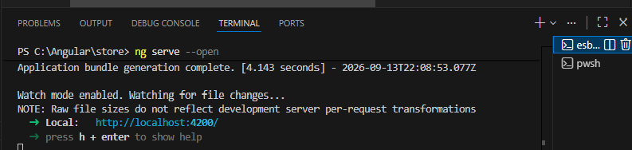

- In product-card.ts, let’s declare a new 2 inputs input(). One is required, another one is optional
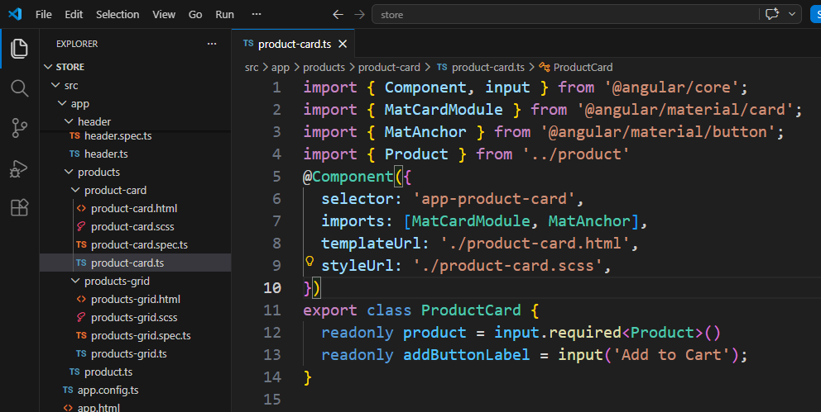

- Next, we need to display each product details in every card. In product-card.html
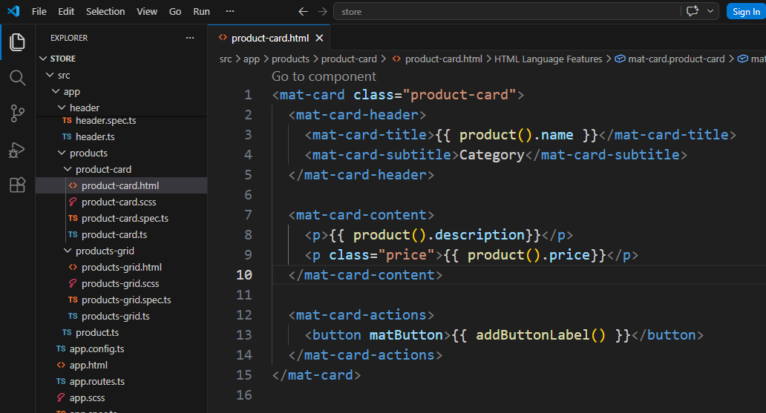
- Lastly, from products-grid.html, we need to bind each product from collection to every card
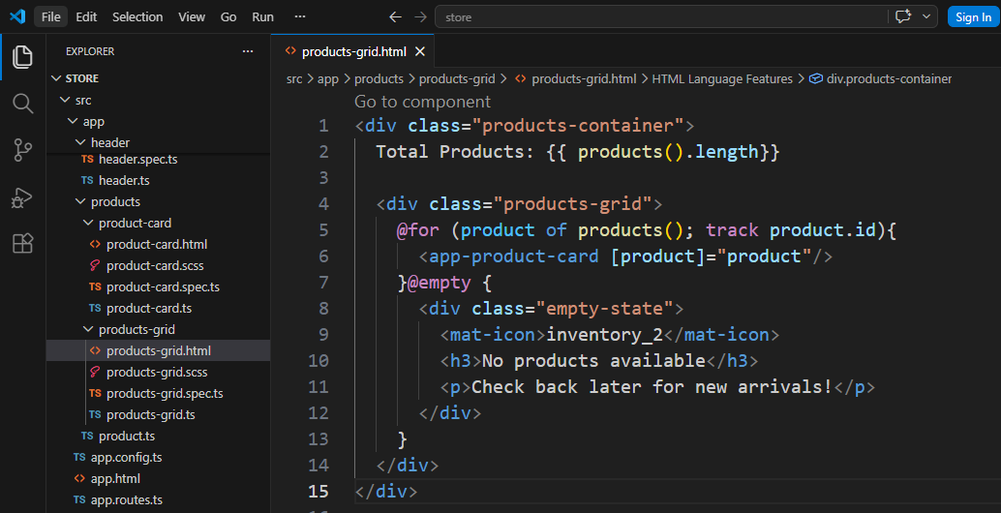
- Save All, now the web page should look like this
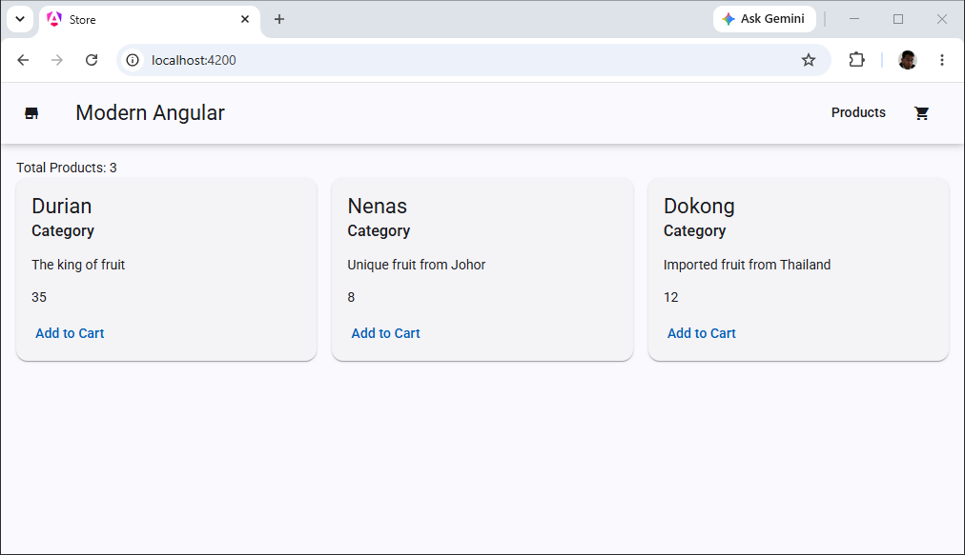
- Back to product-grid.html, remove the “Total Products”
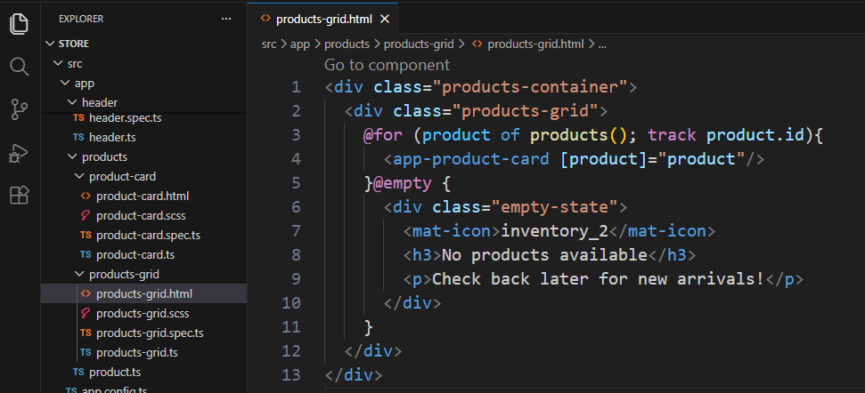
- Back to product-card.ts, change the button label to “View Details”
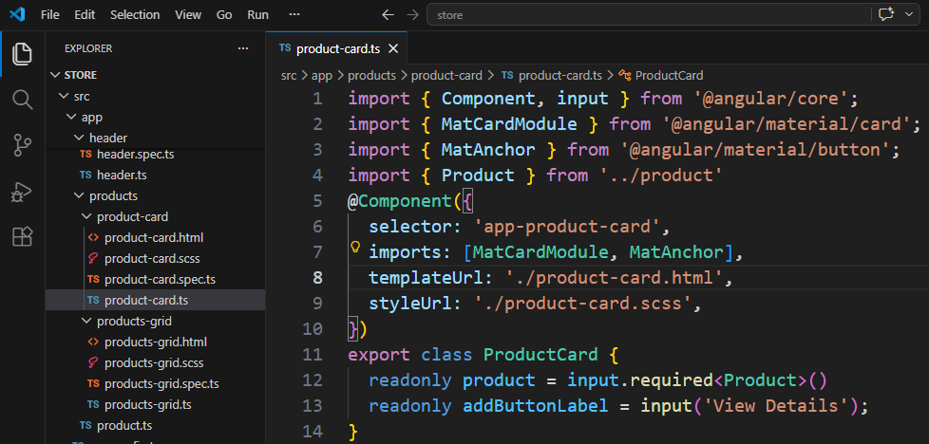
- Save all. Now the browser shows
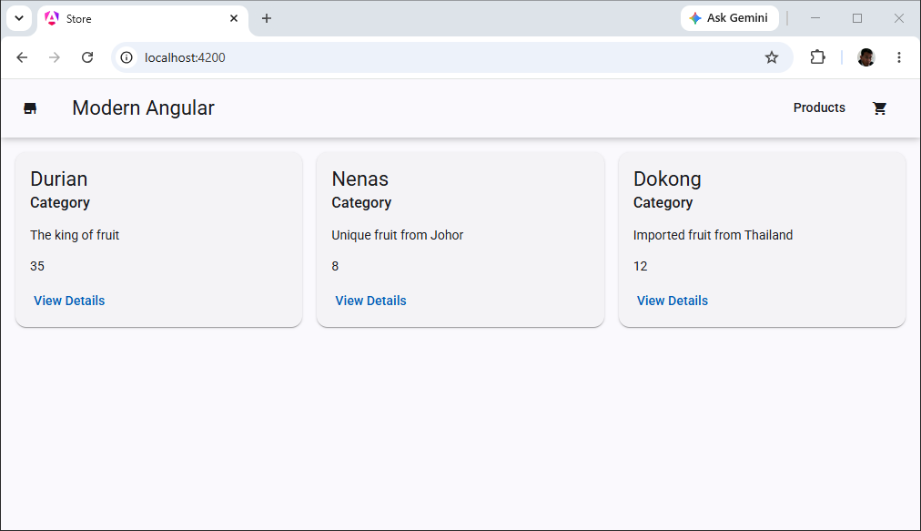
- Close VS Code

- Backup/Zip the application as store(Ex11).7z

